Rebar Ali
Soumick Dasgupta
Alex McLaurian
CS551 Advanced Software Engineering

- Import Existing Services/API
  - Google API, LightBox Libraries, HTML5-Geo location services.
  - Sign-up form with Javascript and jquery check for password and email address and send email notification.
  - Sign-in form, validation, redirection to home page.
  - ASP.Net web pages to handle sessions.
- Detail Design of Services
  - Our website is based off the standard idea of having a user register then login in order to access information. Once logged in, they can access the various pages that contain different features (managing photos, GPS services
  - We needed to allow users to upload and manage images, as well as having a way to keep track of which images belonged to which user, so we designed services for photo uploading and viewing.

- Implementation
  - All previous HTML pages had to be redesigned in ASP.net in order to correctly implement Session storage
  - Photo viewing was designed through ASP.net, and connects to the cloud's local machine where the user's image folder is located
  - Photo uploading was designed through ASP.net, and allows both mobile and desktop users to upload their photos.
  - Our profile page was redesigned with strong utilization of Jquery Mobile
    - We've run into difficulties with Jquery Mobile and DOM
  - We also implemented the ability to edit our profiles.

- Testing: After conversion from HTML and WCF to ASP.net, encryption tests were done again to ensure the same processes still worked.

- Deployment:
  - (Sign-Up) http://vhost0221.dc1.on.ca.compute.ihost.com/aspnet_client/Login_Webform/Login_Webform/Account/Register.aspx
  - (Sign-In) http://vhost0221.dc1.on.ca.compute.ihost.com/aspnet_client/Login_Webform/Login_Webform/Account/Login.aspx
  - (Home Page) http://vhost0221.dc1.on.ca.compute.ihost.com/aspnet_client/Login_Webform/Login_Webform/Account/Home.aspx
  - (Upload Images) http://vhost0221.dc1.on.ca.compute.ihost.com/aspnet_client/Login_Webform/Login_Webform/Account/UploadImages.aspx
  - (View Images) http://vhost0221.dc1.on.ca.compute.ihost.com/aspnet_client/Login_Webform/Login_Webform/Account/ViewImages.aspx
  - (Github) https://github.com/rkurdi/Increment-2
  - (Scrumdo) http://www.scrumdo.com/projects/project/project155/iteration/78649/board#

- Project Management: update your project ScrumDo site with the progress and plan of your project and include the URL
  - http://www.scrumdo.com/projects/project/project155/iteration/78649/board#

Screenshots Report

NUnit tool
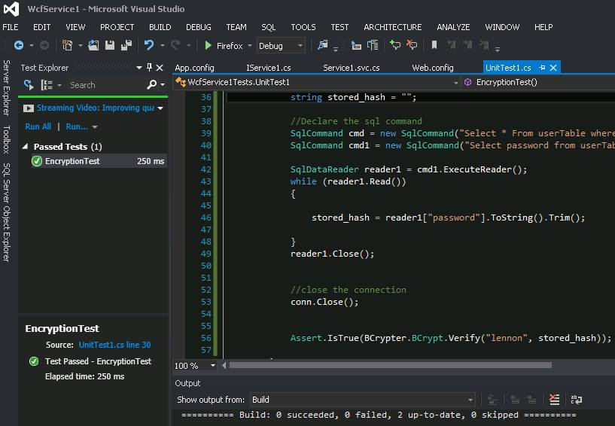

Password Encryption (DB):
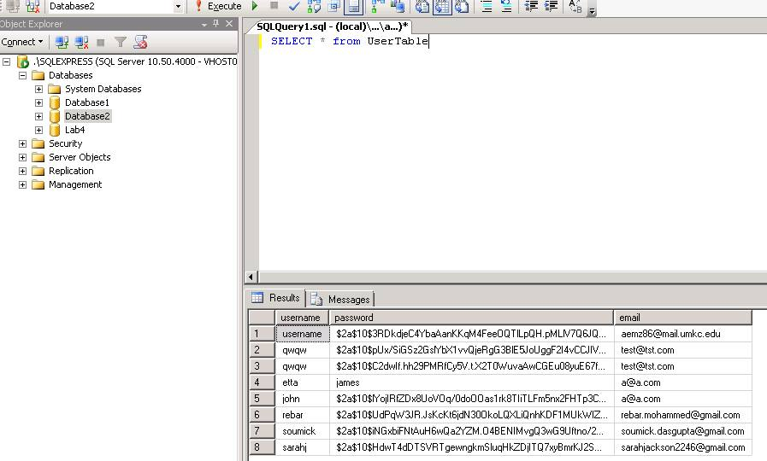

Edit Profile
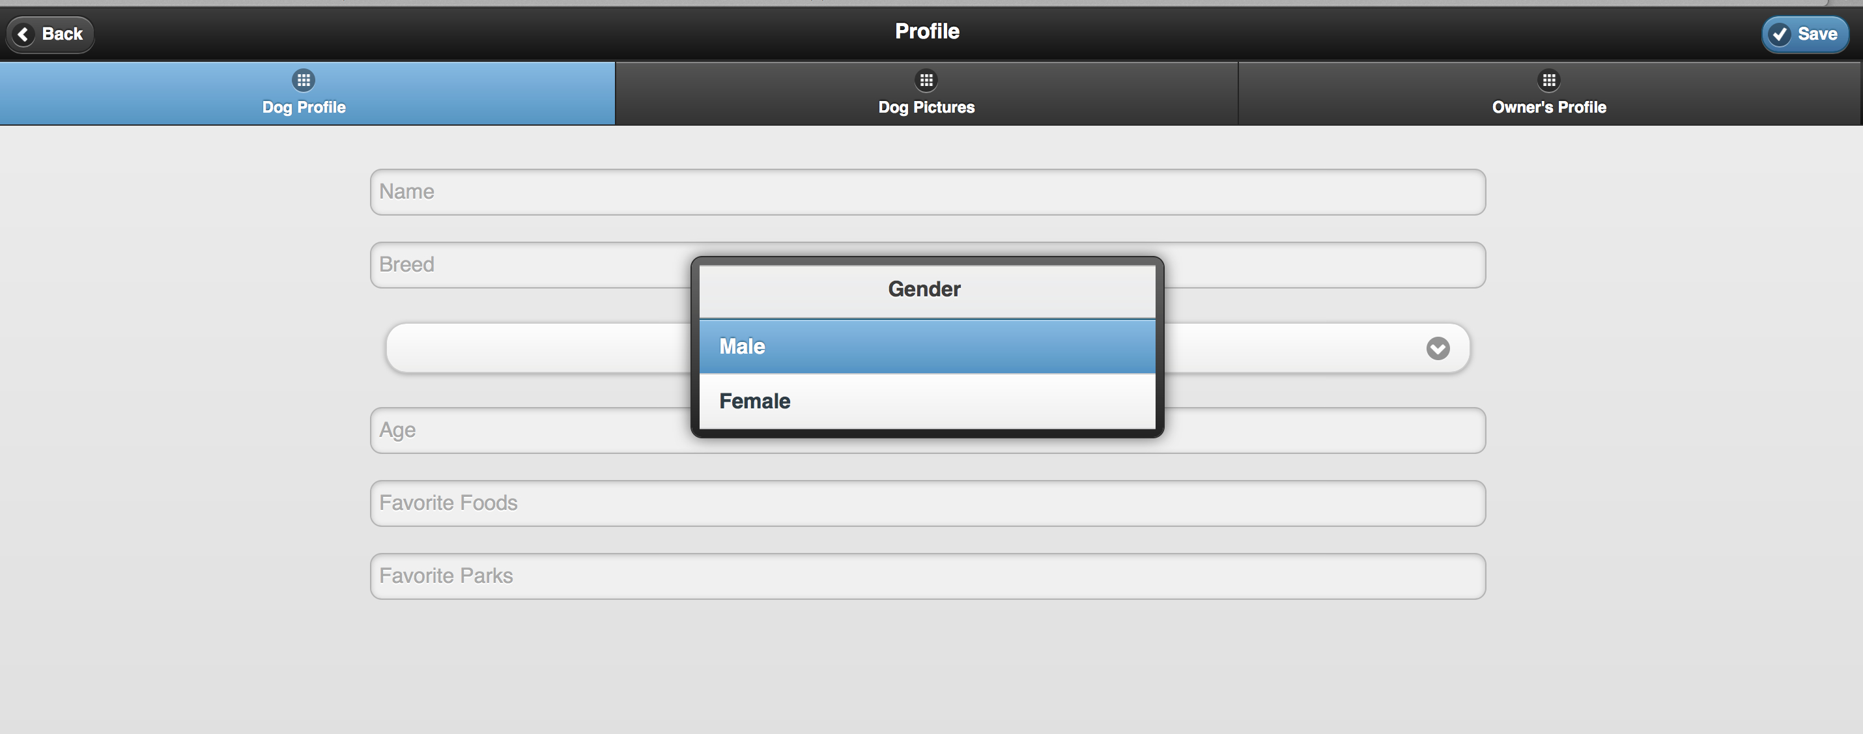

Email-Notification:

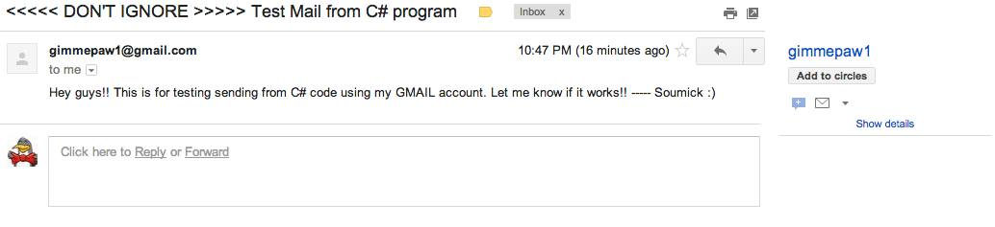

Google Map API
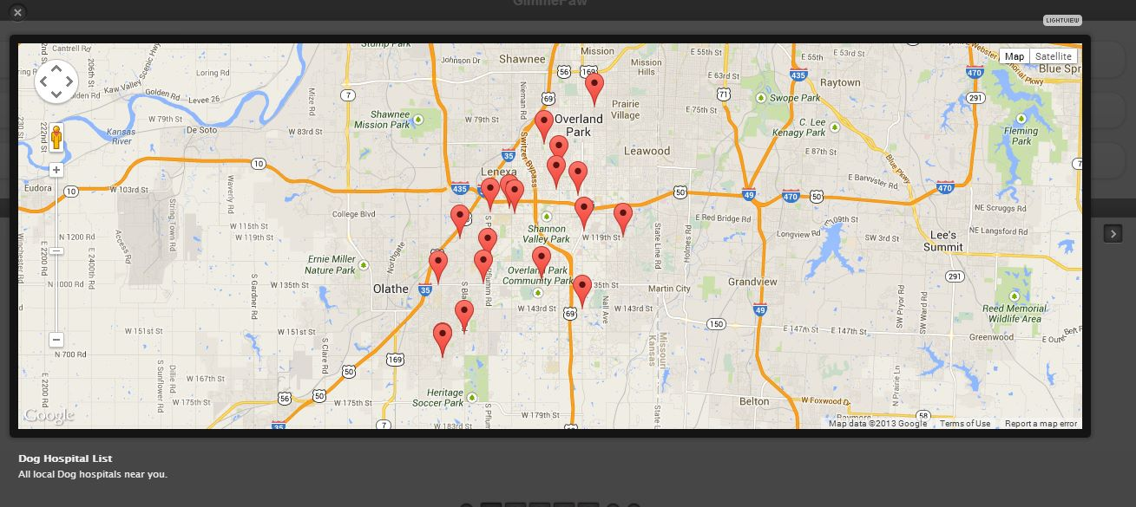

User Registration:

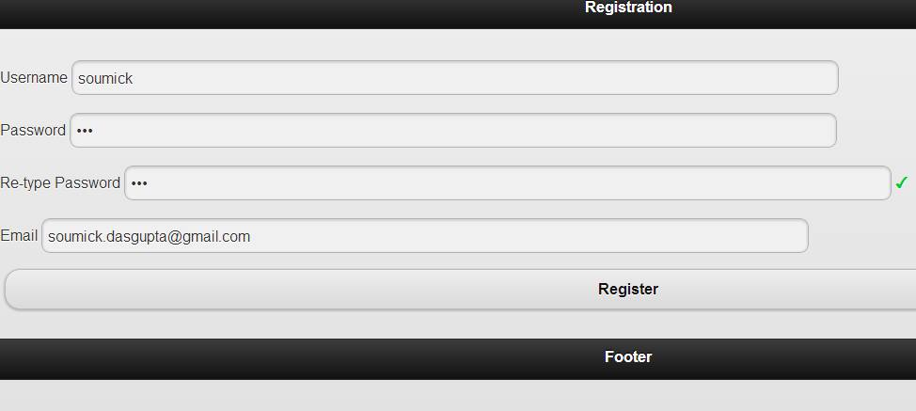

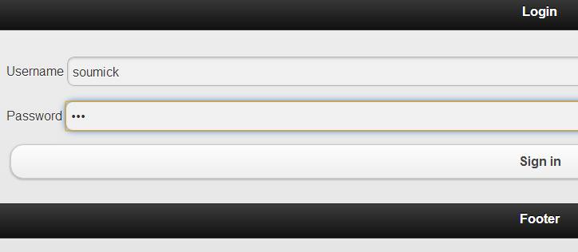
User Login

HomePage
